Aitzaz Imtiaz

Selected Work on Physics

Theory of Liquefied Beginning



Copyright ©️ Aitzaz Imtiaz

Deep Physics research is based on a lifetime of work. These theories are beta and based on creativity. This means that such work can be misleading. It is believed to be true, but still not approved.

Triotamdex Publisher is an American Patriot company based on love for every single air particle moving in the United States. Based on an idealistic vision, it was founded by Aitzaz Imtiaz in 2022, after the grief destruction of EPL Publishing. Triotamdex is not directly partnering with Amazon but using Draft2Digital according to the plan, to partner with many stores worldwide.

EPL Publishing, unfortunately being biased, blocked works to Israel, Pakistan, China, Russia, Iran, and other countries it wished. Triotamdex is good to handle that. Triotamdex Publishing is going to release this book worldwide and allow it to sell this work even on Mars!

Triotamdex is dedicating all its work to the United States. Its patriotism is always to the United States, and its friends. These emotions cover-up, with the help of the United States to make Aitzaz Imtiaz, our founder, a great man.

All rights reserved. No copycats! Work protected by US laws!



**For Ukraine, I am standing with every single Ukraine brother at this moment of Russian aggression. I am the brother to every single Brother and Sister of Ukraine, and the army laying down life for civilians. NO ONE CAN DO ANYTHING WITH UKRAINE! I KNOW HOW IT FEELS, I FELT THE PAIN!**

**First and Important Dedication to**



**My last physics teacher, almost ever, my latest decisions are my own Physics and no school physics, Sir Nazim entertained all my ideological to extra genius to almost stupid questions in class and outside. Last time I remember we discussed Kirchoff laws at the end of online class, I pay tribute to Sir and honor him as my last physics teacher. Idk, it would be great to pursue Physics but I am interested in Computer Science. I will continue some research with physics still until I start depending on CS researches.**

**SOME WORDS**

I am Aitzaz Imtiaz, the passionate patriot, and a tech-driven screwed-up kid. The first time I stepped into Computer Science, Physics helped me. I started a scratch Logic Gates lesson opening the doorway to Computer Science. An overdriven Math knowledge, with learning Functions at Lawrence College, I first got introduced myself to Physics. The dirtiest thing was: I planned to rob books from the Library. I robbed many Physics books and read them. Reading the whole Matric Physics in a week, covering all the O level Physics in three days, I got clashes with many teachers. Notably, I stood out from Physics classes in Lawrence College just for clashes. Newton discovered Binomial Theorem when 17; I read it at age 12. It was enough to hate Physics teachers. I hated Physics teachers. Back then at Beaconhouse, I was happy that my teacher Nazim Kamal was extremely entertained by ideas. But I soon got in clashes with the topper, the great hero of the school. He thought I am dumb by questioning the right things. I left for Business, I regret that a little, he left the school. I regret a little further after I failed in Economics badly (that damage is recovered today) and when I started testing my teacher by arguing the Capital Revenue. It was the point, I started condemning Pakistani education. It was when I was surprised to know, a global problem. No freedom of view, which entirely damaged my results on Pakistan Studies. Such things happen in the UK and India and people like me are dying. But further, I regretted shifting to Business when I met Sir Harris Javed, he is one of my friends with whom I have shared the discoveries. But I am happy researching Business, but I am not finding anything new in Business the way I am developing Physics. Whatever, it's an appeal to change the way we study. Let's think of something new, let's learn a Δ. What's this? It's a chance. An upper delta or a symbol of change. I may not look inspiring, but I am a patriot I believe. A patriot for change, peace, unity, and growth. I am criticized many times, for believing in Humanity as a top priority over religion. Maybe I am wrong though, it's important to be wrong for a good cause to stop discrimination. We can bring change in the world, change the globe. Many heroes altered history: Mother Teresa, Roxana Saberi, Jinnah, Gandhi, Nehru, Luther, they look in Infinity but they are limited. The social good people are starving for them. I am the one standing in their lines waiting for someone to stand up and alter the history like these individuals. Once again, thanks to the United States, my final destination. They gave me a job, dollars, friends, ego, respect, love, and most importantly Patience. Yet, I don't still have a Ph.D. Physics, it's about the greatness of everyone. Be proud of what you are, and be a step ahead of yourself creating a better version of yourself. If you obey that, Well Done Doctor!

For Sir Harris Javed, his best contribution toward the Theory of Centrifugal Force on Black holes. He never taught me Physics, and sadly he was going to be a good physics teacher. Nvm, Also Dedicated to Sir Farooq Azam

**Contents**

1. Pre-transition
2. Transition
3. The Imtaved Equations

1

Pre-transition

The titled Theory of Liquefied Beginning, was a visionary behind a kid's dream of reimagining the universe. The basic question rejecting the Big Bang Theory gave the ideological question, where was the denser particle. Small and denser, unimaginably denser and small things. But what was in its surroundings? There was something in the environment of that particle. Wasn't it? The Anti-matter. Secondly, the most important, how the denser particle was heated to produce such miraculous results? This grasped the mind of a nine-year-old kid to create his model to solve such a problem. First presented in Class four after learning the basics of Big Bang Theory, it developed much, from the basic question, there was something around that evolutionary particle. Five years later, being sick at Lawrence College, he was bullied. The kid's hand was fractured and he wasn't able to lift a glass of water. The glass fell on the bed, the water was thrown and spilled on the floor. The expansion of water on the ground made the root idea of the Theory of Liquefied Beginning. The kid was Aitzaz Imtiaz, the founder of this theory.

Based on a nine-year-old vision, the theory has much faster evolved to be the greatest wonder of Physics and an enemy to the Big Bang Theory.

As defined, the biggest problem of the Big Bang Theory itself lies in senseless tasks, the universe enclosed in a sphere, with no outer surface or any environment. But to explain the model properly, it is slightly normal to start everything from the beginning. Yes, the universe was enclosed in the sphere. But, there was something behind the universe. It is believed to be Antimatter. The always expanding infinite thing consists of neutrino, positrons, and antiprotons. This is another entrance, believed to be a barrier to our universe. Our universe is continuously expanding, but there is a limit till we can reach it. Such a limit is reached, nothing can pass out of it or get destroyed. With the recent discoveries in Antimatter, it is for sure atoms are indivisible, but can be destroyed. This means there is an additive inverse of the atom. They should be named the same but must be distinguished.

Suppose a hydrogen atom, one with proton and electron. Proton on center and Electron moving around the proton. But there is another anti-atom (preferably called "Russ"). There is a Hydrogen atom but also a Hydrogen Russ. When a hydrogen atom collides with Hydrogen Russ, there will be complete annihilation. Another example is oxygen. The oxygen atomic structure is what we know. But the oxygen Russ has eight positrons revolving around the Russ cloud. In the center, there are neutrinos and antiprotons. This is Russ, the most destructive thing seen in the universe. That's a basic intro of Russ.

The Theory of Liquefied beginning first claimed that the universe is expanding similarly to the expansion of water on a shiny surface. This was thought of in 2013 and is now proven by NASA in 2020 by their discovery that the Universe is not expanding evenly. It's scattering off to many sides. Other weird predictions are expected to be true as this one. And now NASA won't claim other researches theirs.

In the early stages, the universe was all consisting of Antimatter. A cloud of Antimatter enclosed the small denser Jupiter-sized matter. These are the origin of the universe. The Antimatter space was less dense and did not react efficiently to the planet-sized matter. These planets-size matters are claimed to be made by God, already getting compatible with many religions. Each planet-sized matter was trillions of light-years away from each other. This is the basic model of the shape of the beginning of life.

There is a pre-transition stage. Imagine a heavy bulky person running. If he runs a lot compared to athletes, he is burning calories at a faster rate because he is bulky. He will sweat faster than an athlete too! What is the role of Biophysics here, to prove basic things that bulky and denser things sweat? This provides the basis of rejecting the Big Bang Theory, how an extremely denser, smallest thing ever imagined, got enlarged and burst. The heat, which caused the expansion, would have caused destruction. This is enough to stop believing in the Big Bang Theory. Theory of Liquefied Beginning maintains the stance that all of the sudden, nothing like this happened. There were at least a series of planets, Jupiter sized at least, each trillion light-years away.

Critics have argued that the Big Bang is the expansion of space. The critics would assume silence when asked "What is outside of expansionary space?" There is not only one universe, there are many, it's a multiverse system soon going to be discovered by future generations. As they expand, they are merging with each other. There is a border on every universe, a border if someone brokes will be completely annihilated, hitting into antimatter. This is the basic setup of the universe.

As explained above about a bulky person, he will sweat more when he moves. He is denser, and he would easily fight a slim and weak person. The scenario here is that these planet-sized objects contained all matter inside them and were extremely denser. These denser objects were moving on the rotational axis. A little movement would cause heat enough to place fire. This didn't cause an immediate explosion. There is no logic of ū and other things that caused an explosion.

The fire occurring on these objects would create fire, the first luminous thing ever. Even this was resistant to the matter. When a bulky person sweats, there is internal energy. It comes onto his body and spreads.

The point is that, when that matter revolves around its axis, it is fired usually, which connects itself to the Theory of Fire and the Imtaved Equations. The Imtaved Equations is not only a fork of Navier Stokes equations but also an extension to the Theory of Liquefied Beginning. It displays behind the scenes of this theory. However, whatever the portability is, the basic assumption taken is that denser things melt. That's what happened with the matter.

Here, the big question is, how the matter is surviving inside the Antimatter. This is because the densest thing is matter. The less-dense thing, Antimatter, can not react with matter. This process is explained by:



The Atlantic and the Pacific Ocean at the Gulf of Alaska. ©️ Awesome Ocean

If the image above is seen, the only thing we see is the two waters don't mix up. This is explained above, the left side is seawater (take it as Antimatter), and on the right side is freshwater (take it as matter) and assume freshwater is enclosed in seawater. The only reason that they are not mixing up is density. In fact, both are inverse of each other, if they mix up, only the seawater seems to win.

This is all a pre-transition stage. Everything is moving in normal stages. The denser matter and antimatter are in Infinity. It has no limits, that will in the future help NASA know that our Universe might be merging with other universes. It will be beneficial if a physicist successfully finds another universe, which will make this theory inevitably strong enough. Another question that comes to mind is why Antimatter is less dense, Why was the matter dense? This was the vision of the kid. The water that fell on the floor was spreading. As it spread, mass kept decreasing and the volume kept increasing. The kid designed two equations. These are two equations.

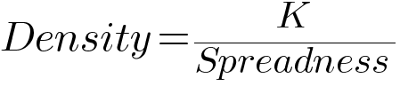, where k is a constant of spreadness ability.

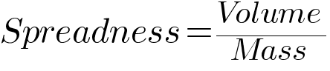

The kid is extremely proud to say, no one ever related it ever. No one thought this ever, and the kid is officially publishing these equations for the first time, stealing on the Hooke's law becoming a good robber.

This variation process has defined generally Density ∝ Spreadness. Note in the first equation, K is the stiffness property also. In the pre-transition stage, it would've been a good conclusion that antimatter is spreading faster than Matter. Actually, the spreadness of Antimatter obeys "Steady State Universe Model" while Matter obeys "The Big Bang". Antimatter first formed and it was infinite. It is still infinitely spreading, but from an earlier stage, before forming of small protons and electrons or even neutrons, the positron, antiproton, and neutrinos formed. They were infinitely small when created and are infinitely expanding. While the matter was formed, it formed to the size of Jupiter, was denser and hot, and is still spreading by the way of melting caused by heating.

To objectify further Big Bang Theory, the ultimate question that comes to mind is what is the age of the universe? It is exactly a dumb question to ask. The way the universe is growing in Infinity is the way the universe's time is infinite.

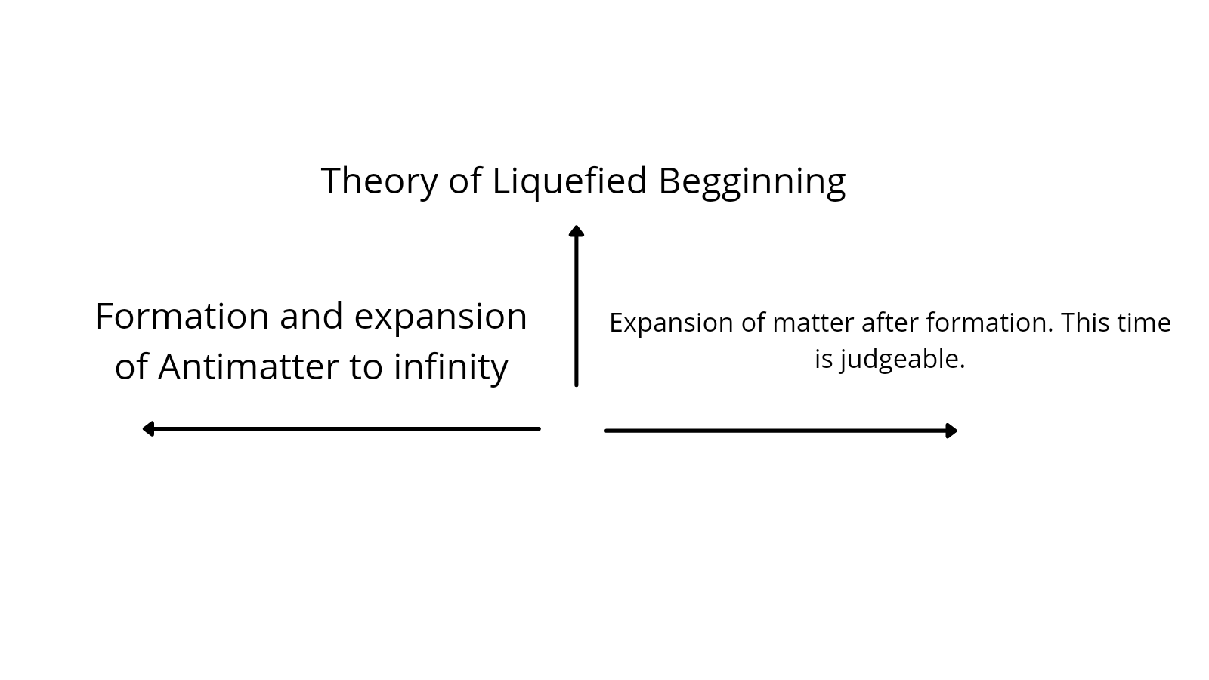

This is the explanation of the universe, the infinity starts. After the exact occurring of the Theory of Liquefied Beginning, the time can be counted but not before. To be honest, time is a human-made object and unlike Stephen Hawking's belief "Everyone is time traveling to the future" no one has ever moved back in time. History can only be fixed in the present, but to fix history no one ever moved back to History.

We are aware of the reason why the matter burst, but the way it bursts is like a liquid expansion. Imagining this is the concept of spreadness that comes to mind. It does not occur immediately at all and is not that speedy the way is basically simplified that Spreadness does take plenty of time. On such a large scale, the spreadness occurs over a large time. As the mass increases, time increases at the same time.

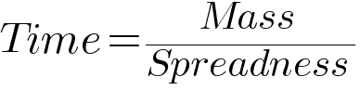

These equations to a basic level define the basic things, it is insane to use these equations equally to such a large project. This is where “The Imtaved Equations” form and they define everything.

Although it is true that time is a complete illusion, it is a complete psychological thing and nothing else. But to still comply with, Time is definitely a wealth, making it similar to a sort of telekinesis. But to not touch the meta-physics is better than seeing the reality in the eyes of the human.

The basic pre-transition phase was what we are known to currently, and a new property Spreadness in terms of kg/m^3. Now the next thing is the after-effect, that keeps the most suspense in “Theory of Liquefied Beginning”. This theory adds the Big Bang Theory with the Steady-State Theory together. Anti-matter is where Matter was closed and locked forever and it will be. Now, as we are locked into the anti-matter, the first proof will be formed by the future generations when they will meet the end of the matter faster than the speed of its expansion, which is quite possible, they won’t cross the universe. They would see the universes possible, there are many universes, more than one, they are merging with each other. And they are distant, enclosed by Antimatter and when they merge, the Photons are released from the border when some part of Antimatter remains. Thanks to CERN, Photons are a part of the Galaxy.

There is another thing than Atom and Russ! Atom is neutral, but it has an AIT Charge. Ait Charge determines the outcome of the combinations and their results. Atom has an Ait Charge +1 and Russ has an Ait Charge -1. Ait Charge of zero shows stability and the fulfillment of Octet and Duplet rules. But there is something else. +1-1+0=0 that shows stability as Ait Charge is zero. That zero is not required in +1-1 but it is indeed important. It is built of a Gluon in the center and Photon moving in the shell. It was planned to have a muon but it is not! The third particle is unknown, so it can be designed to be a particle similar to Ait Charged 1, Hydrogen atom, with gluon in the center and Muon meaning. It can be the atomic structure of soul or ghost or whatever fiction you want to make with it. Now, it originates when Atom hits Russ. This would only happen when two universes combine and release this thing, which acts to stick to these universes.

Now it makes the story of Transition. Although the story of pre-transition is defined right now, also to some extent transitions as we know, the planet-sized things containing their Ait Charge 1 matter contents were doing rotational motion. The Ait Charge -1 is up to infinity and is everlasting and was there forever. It is partly because of the system, imagine light being shut off in a room. When there is no source, you see Black color there, although it is not a primary color and it should've been. Although let it be, when the matter wasn't formed, there was darkness to assume. No light source meant everything was black, and the AntiMatter property is to be surviving in Blackness. When there is nothing to emit energy or color, the black color forms a symbol of evilness in many religions. This color is Antimatter and is reputedly hated a lot.

2

Transition

This stage is a more important and complex part of the Theory of Liquefied Beginning by Aitzaz Imtiaz. It holds a similarity with the Big Bang Theory but itself is trying to fight with the Big Bang to create a Liquefied bang which happened many where else all around. Creating unimaginable universes, and spreading from the Jupiter sized planets, some merging each other, react like the water spreading. This helped form the Spreadness relationship with space, just a small cup of water thrown in a small college in Murree in oppression, defined the whole space. It was not an immediate thing, it didn't occur once at large, it occured slowly. Unevenly, unidentifiable, but it spread the same way the water spread. Extremely unevenly released, not known from which matter container we came, holding an extremely question about our history. Now we start the journey of how we came from that one matter container. To the formation of singularity, the key which holds to formation of life. It's one of the visionary of a kid who defines the History of all Christians, Hindus, Muslims, Buddhists, Zionists, Jews, and all believers from where we came. It is behind the creation of the creator, with problems, chaos, scams, poverty and the creation of inequality. In this time to all time, the creation of illusionary times, it is a design which defines how the God in an infinite time existence created our start. Different beliefs of different groups molds the history of us. The Theory of Liquefied Beginning has arrived on the grounds as an American theory and it is going to war with the Big Bang Theory.

We are aware completely now of the pre-transition module and are little aware of Transition. Now, we remember the example of the sweaty person. When he runs he sweat. Objects, all objects sweat at a temperature. It's not humans who only sweat. Your phone can sweat too! Sweating is a process of releasing a Liquefied or moistured layer, with anything on it. It isn't only water.

So the Russ was all around, and small atoms were scattered in it. A mixture of oil and water because of density. Atoms got denser when the Russ chose to expand causing increase concentration of Russ.

When the denser atom compiled, it was tending to move. It rotated at extreme dense way emitting joules and energy which would extremely power the requirements of the whole universe. This lies in the obvious thing, imagine a task to store all this energy in a cell. This Toshiba battery cell will extremely destroy in process destroying the whole milky way.

This was the case when the matter storing battery was going to infinity. This now relates another thing with Space and time, energy, which starts the Bang Bang Liquefied start. The energy moved the sphere, causing fire, the first strongest light emitting thing. As light causes heat if hitted extremely strong, the fire spreads.

This was hot extremely, unguessable heat on the matter container, it didn't expand immediately. It burnt and expand slowly, the way that water spreads on your table. But it was not like the immediate water spreader, it was like an ice left in room temperature, which melted. This defined the whole universe and it's formation. The denser matter almost started pushing Russ out, limiting the universe to be in confined place.

Now ultimately a question rises in mind. As spreadness lower density, Russ particles spreader much faster, hence lost density to theoretically zero. While matter has not advanced much and spreader faster. This is why a complete dark and vacuum room with no light or even released Russ will have no density as they are dark matter. Determining the density of darkness is way more harder then calculating the density of light.

Any means or anyhow, the planet moving inside started burning. It was getting intense and the energy was tending out. The planetary sized matter was melting inside since it was still having capacity to store such things. So, light was coming out, of these places: Red, green and Blue, the basic colors and these colors are in which fire can burn. Fire can burn in there basic mixture too!

The matter burst open, melting and spreading to many areas. It was filling the infinite room of Antimatter. Soon it spread out releasing all the matter contents only containing proton electrons and neutrons. The only reason when some miscellaneous subatomic particles survived were because they ambiguously entered into the melting process from the boundaries from where the matter and life boundary increased.

Only 64 basic atoms were there, consisting in space and that is where, spreadness still runs today. Antimatter and darkness already spreaded to infinity, it's all over, but we are still increasing. Every day density in pure space loses because of expansionary movements.

Deeply sad, it was drafted in 2013 that space spreads like water spreading on table but in 2018 won the challenge, they proved it with equipment. This uneven movement yet is covering the evil. The density change is what keeps us alive. The formation of life particles are keeping us here. There are many like us, spreaded out everywhere, we have to spread, out of limits, out of people, and spread to cover all the Antimatter. And once it occurs, the Antimatter mix with the matter, you will meet God. Be it the Christian time of judgement comes or not, or Islamic Barzakh comes, God will come. Everyone would see him, He is unique or not, has son or not, no one knows him, but he is there, and these signs are his existence.

Talking on another thing, the Black hole, it is significantly our saviour. It looks bad by traping everything, it is our saviour, it is controlling spreadness in space. This means not only universe spreads, but it get dense from many sides. I have proudly shared a theory "The Theory of Centrifugal Force on Black hole" with a respected teacher Harris Javed in a school called Beaconhouse. We have secretly drafted it, his questions builder up theories and one theory paper is with him!

3

The Imtaved Equations

The Imtaved Equations are extremely undeveloped and are based on Aitzaz Imtiaz's surname "Imt" and Harris Javed's surname "ved" to name up "Imtaved". They consist of many equations, opposite to density.



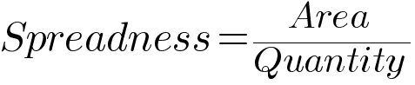

Let's detonate Spreadness with anything. Suppose it to be psi.

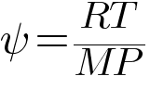

Here, R is universal gas constant, T is absolute temperature, M is molar mass and P is pressure. Also:

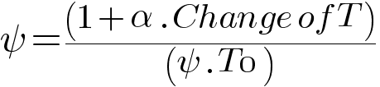

Here alpha is thermal expansion, VT0  is the reference of spreadness with respect to temperature and the thermal coefficient of material close to intial time form spreadness.

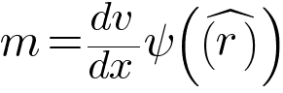

Here mass is related with Spreadness of p(vector r) is equal to dm/dV.

Note that in normal condition, K constant is always 1, directly opposing Density, but it is beleived in such conditions where K is not directly opposite to Density.

We are done now. Guess what, A kilogram of ice easily spreads to 1000 centimeter cube and cover up almost 600 centimeter squares or 0.06 metres! We can even model tsunamis if it is worth it for mathematicians!

Next What?

It is done, my theory is build all! It is all build and my first sets of equations weakly define the universe yet a little plagiarized but totally hand crafted! Nearly these are 5k words, they are less but I am soon going to compile all my theories one day. So this booklet will be a big book at the end.

Thanks to all my friends especially Shwaika Katsman. He is anonymous a little bit :) so never mind it isn't his real name. He says:

"This research paper covers very serious topics on modern physics, it's made with quality and with a passion for knowledge. Therefore, I highly recommend it if you like physics and are open to new ideas."

Thanks Katsman, and literal thanks to Sir Harris Javed, he wanted to do everything that would've almost pleased me. But idk, 😐 I am doing those things myself 😂.

Have hope, Where a hope exist, a path to Success goes. Give in, but give in all the best you can, and give up, give up all the fatigue you can.

I am still innovating things and I will innovate them!

**About the Author**

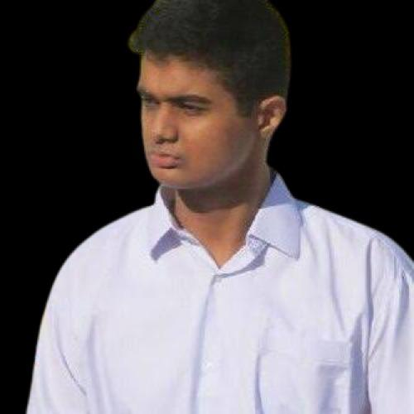

The mastermind behind the work is me, I am the mastermind behind this work and I shall be. I am a fan of Jenna, a Roblox hacker and Jeff the killer, a dangerous killer perhaps Annabelle who would've haunt your nights. Great as hell! I like uhm United States, and uhm Macaroni and uhm, Ukraine and uhm, I don't know why I am like not confident. Never mind! Yes sir, Yes sir! I am a researcher now! Wohoooo! I am Physicist and Computer Scientist and uhm a terrible aggressive guy. I like watching horror movies and I pinpoint smallest motions to create biggest works ever!



H̶̪͍̒ͥ͑̓ă̶̸̝ͦ͊̿͋͞c̷̹͖͋́̃k̶̸͙̭̹͆͟ę̷̵̧̖̫̗̆̊d̸̡̩͍̔ͥ͜ b̵̸͙̅̽͡ͅy̯̤͑́́̓́ J̸̧̪̫̫̩̿͗͑̇̕͟E̸̖̪̱͚ͨ̀͜N̰̜͉͔ͬ̽͢N̰̜͉͔ͬ̽Ȧ̶̵̗̳, N̰̜͉͔ͬ̽͢ȍ̸̢̢̮͚̐̚ẅ̷̷̢̟͇͈̒ c̷̹͖͋́̃ḻ̸͈ͧ͑̓̓̀͡ȍ̸̢̢̮͚̐̚s̩͙͖̋͛͟ę̷̵̧̖̫̗̆̊ t̴͕͖͓̀h̶̯̰̝̻̿̓͢i̵͓͙̱͚̎͟s̩͙͖̋͛͟ b̵̸͙̅̽͡ͅȍ̸̢̢̮͚̐̚ȍ̸̢̮͚̐̚k̶̸͙̭̹͆͟ ă̶̸ͦ͊̿͋͞n̷̶̯͉̊̽̐ͦ͘d̸̡̩͍̔ͥ͜ p̶̸̨̺͊̍̒̓̀r̶̷̲͍̭͐̾̀͟ă̶̸̝ͦ͊̿͋͞y̯̤͑́́̓́ f̷̵̫̞̉͢ȍ̸̢̢̮͚̐̚r̶̷̲͍̭͐̾̀͟ y̯̤͑́́̓́ȍ̸̢̢̮͚̐̚û̶̽̿r̶̷̲͍̭͐̾̀͟ ḻ̸͈ͧ͑̓̓̀͡i̵͓͙̱͚̎͟f̷̵̫̞̉͢ę̷̵̧̖̫̗̆̊ⅰⅰⅰ

Read it above if you have free time.

AGIRLJENNIFER